Granite Gripper
The Chatham Granite Club
3/27/2017 | 41 William St. N Chatham, ON, N7M 4L3 519-352-4324
Chatham Granite Club
e: granite@ciaccess.com
facebook/ChathamGraniteClub
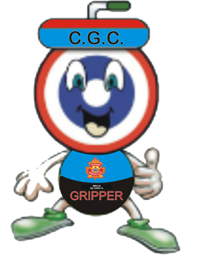
Message From the President
Wow another year of curling has flown by!
A big thank you goes out to Rob & Cole Abbey for replacing our broom heads on a regular basis. Aiden Poole for all his time spent working on our web site, along with our other social media sites. Check them out www.chathamgraniteclub.com.
After some work and recommendations from our ice committee, we had a representative from the OCA pay us a visit. We have just received his final report and Mark and DJ are planning on doing a few things over the summer to make our ice better.
There are several functions happening during the off season this year, please make note of those listed on the left and support those you can.
A big thank you goes out to the coaches, instructors, bakers, dish washers, cooks, bonspiel organizers, score keepers, ambassadors, league coordinators, board members, helping hands- with repairs, lawn cutting etc. the list is endless!!
Without your help in and around the club, we would not be able to do what we do for our members and the community.
Our junior program is growing with the development of the inter club bonspiels which is a landslide success. This may be the ticket to growing the sport for the junior curlers. Thank you Don & Rob and all of the coaches who help out.
The Elementary school program has increased in participation again this year. This program helps provide an introduction and instruction to the youth about the great game of curling. Having a large pool of volunteer instructors is a key. If you have an interest to help our city’s youth by assisting with this program, please contact the office or Don Braddon.
Our membership is up this year thanks in part to the –‘ learn to curl program’. Our team of Ron, Mary, Keith, Reg deserve a huge thank you. This program helps new curlers become comfortable with the game in a structured but safe environment. We are planning on tweaking this for the next season, to make it even better. So if you have a friend who is thinking about curling- recommend they try this great program.
Our bonspiel season was full and successful due to a number of people; the conveners- and you to the members as well for supporting these events. Thank you!
Our club still has some work to do to maintain the building and we will continue to look at items for repair and replacement. Thank you to everyone who has drawn our attention to some items and or helped with repairs. We managed to secure a couple more grants this year and hope that during the summer we can replace some of the deteriorating siding along the back and side walls, along with the dehumidifier. If you have any interest in helping with the siding please let the office know. Our senior members have again stepped forward and both of the Tuesday leagues have donated funds for repairs. Thank You!
We are always looking for ways to make your club better, if you have ideas, we are interested in hearing them. We will be looking at things to do in the club over the summer to attract more traffic. Please continue to support these functions as we try new ways to make use of this great facility throughout the year.
With the Annual Meeting coming up on Wednesday May 24th we are also looking for a couple of new board members. Please consider one of the positions to help guide our club as we work to provide a great curling experience for everyone.
Shop local is important. By visiting local businesses that support our club, with sponsorship and donations/ prizes, you show these businesses you appreciate their community spirit. They provide valuable funds that allow many programs to continue. Please check the list and say hi, when you have the chance to grace their doorsteps.
Have a safe and enjoyable summer and we look forward to seeing everyone back on the ice!
Dates to Remember

Plant Sale- orders due Monday May 1st

Annual Meeting -Wednesday May 24th

Beer Can Chicken Dinner - June 24th

Golf Tournament Saturday Sept – 16th

Open House – Oct 18th
League Start – Oct 30th

Getting Involved
There are still lots of opportunities to contribute to another successful season at the Granite Club. Ask one of your board members how you can help.

- Become a member of the board
- Volunteer on a committee
- Help out at bonspiels, fund raising events and brunches.
- Attending fund raising events

We are looking for a few members to join the board. We are especially interested in expanding the voice of our members. We welcome new curlers and curlers representing each of our leagues to come out and help the Granite Club.
- Not sure how you could help? Curious what’s involved with becoming a board member? Contact the club or speak to one of your current board members they would be glad to spend some time with you.

- Not sure you have the time to commit to being a board member? How about volunteering to be on one of our committees this year? This is a great way to lend your support and expertise to a board member and your club. Commitments can range from just a few brainstorming sessions to as much time as you can offer each of our board members. To learn more drop your President an email (that’s what he’s for). randmac@cogeco.ca

- Current openings

- OCA rep- brief points of the job description- represent the Club at functions and liason with the OCA. Be responsible for the all aspects of the clubs participatation in OCA events. Apply for OCA events the club can host and work with the club manager to ensure facilities are available to the teams participating.
2 – Membership – we are looking for an additional person to assist with the promotion of the the club within the community to encourage the recruitment of new members. Arrange media coverage for events, bonspiels and league results. Coordinate the Gripper publications

3 – Bonspiels – organize chairpersons for each bonspiel. Help each bonspiel chairperson as needed. Produce a bonspiel flyer for distribution to members and nearby clubs, with dates at the beginning of the season.

Member at Large
This person does not need to be a board member but has some computer skills and is interested in looking after communications. This would be the Gripper and a monthly email to our membership and some communication with our sponsors.

Fund Raising
The committee has organized 3 brunches this year and had one of the most successful years yet..

Our last brunch of the year will be this Sunday March 26th from 10:30-1 pm. We are always looking for new volunteers to help with cooking, serving and cleanup. Donations of desserts are also greatly appreciated. After over 25 years of organizing and running the brunches, Bob and Marian Allen are retiring from the position. A great big thanks goes out to them for all the years of dedication they have put into the Chatham Granite Club fundraiser. We plan to honor them at our upcoming Annual General meeting in May. Please help us show our appreciation

We managed to secure some grants this year that will help replace the dehumidifier. As well the Day Ladies have offered $1200 towards a new ceiling in the lounge. Both Day Ladies and Men have donated additional monies for the kitchen and repairs. Thank You!

Reg Johnson

On Ice Advertising
During the past off-season, the club has had a group composed of Larry Wood, Rob McKay, Rand MacIntosh, Reg Johnson, John Young Jr and Ron Robertson contacting both existing clients and prospective clients who might wish to renew their existing ad or place a new ad in the playing area.
In order to maintain revenue levels, it is necessary to obtain new clients each season. In the event that you know a person or business that might be a good fit with our club that is not currently advertising with the club, please approach one of the above persons. We would like to prepare a list of prospective clients for the 2017-2018 season.
Submitted by Ron Robertson

Memberships
In an effort to simplify our membership options, we modified the categories for this year and are pleased to announce that our numbers have gone up. This is a great sport and a great value for anyone wanting to enjoy some on ice activity with a great social aspect.
The Learn to Curl program has showed it’s value and is being tweaked, we hope this fits the needs of all new curlers. We are looking to grow our numbers again next year by adding the extra value to this group. Stay tuned for details on what we are working on.

Adult Learn to Curl
We intend to run this program again next season probably during November and December on Sunday afternoons from 3:15 to 5:15. The eight week program is open to existing members for $75 and non-members for $125 and will be limited to 25 people. This is an excellent program for any curler with little or no experience and you need only ask anyone who took the program to verify that statement.

If you yourself are interested, please contact me. If you know someone else who could profit from the game of curling and potentially become a member of the club, please put them in touch with me or bring them to the Open House in October.

Ron Robertson
Convenor of LTC program

Bonspiels
Participating or helping organize a bonspiel is a great way to meet new friends and contribute to the Granite Club. We had many events this year that our members and other clubs enjoyed. Thank you to all those who helped in any way…. a lot of people put in a lot of time and effort go into make them a success.

The Ladies Holly & Mistletoe once again was a highlight of the season. Our Tier 55 events were well attended and our many Charity events are doing well. All of the bonspiels provide another avenue for curlers to enjoy the true meaning of our sport- the fun and friendship!

We look forward to seeing everyone back next year

OCA
Below is a list of teams that represented the Chatham Granite Club in OCA competitions this season.
Tankard Men’s
Dale Kelly, Mark Patterson, Ed DeSchutter, Blair Willert
Fairfield Men’s
Greg Payne, Steve VanHeste, DJ Skipper, Mike Drake
Sr Men’s
Phil Daniel, Bruce Cox, Ross Adamson, Peter DeKoning
Intermediate Men’s
John Young Jr, Dale Kelly, Ben Curtis, Jacques Van Bilsen
Colt Men’s
John Young Jr, Mark Patterson, Ben Curtis, Jacques Van Bilsen
Mixed
Greg Payne, Rachel Faust, Colin Milne, Kim Charron
U21 Men’s
Aiden Poole, Tye Juniper, Oliver Campbell, Devon Weese
U18 Men’s
Alex Jeromel, Alex Gough, Logan Butler, Austin Haddock, Hayden Weaver, Coach Jim Brackett
U21 Mixed Doubles
Tye Juniper, B. Elson

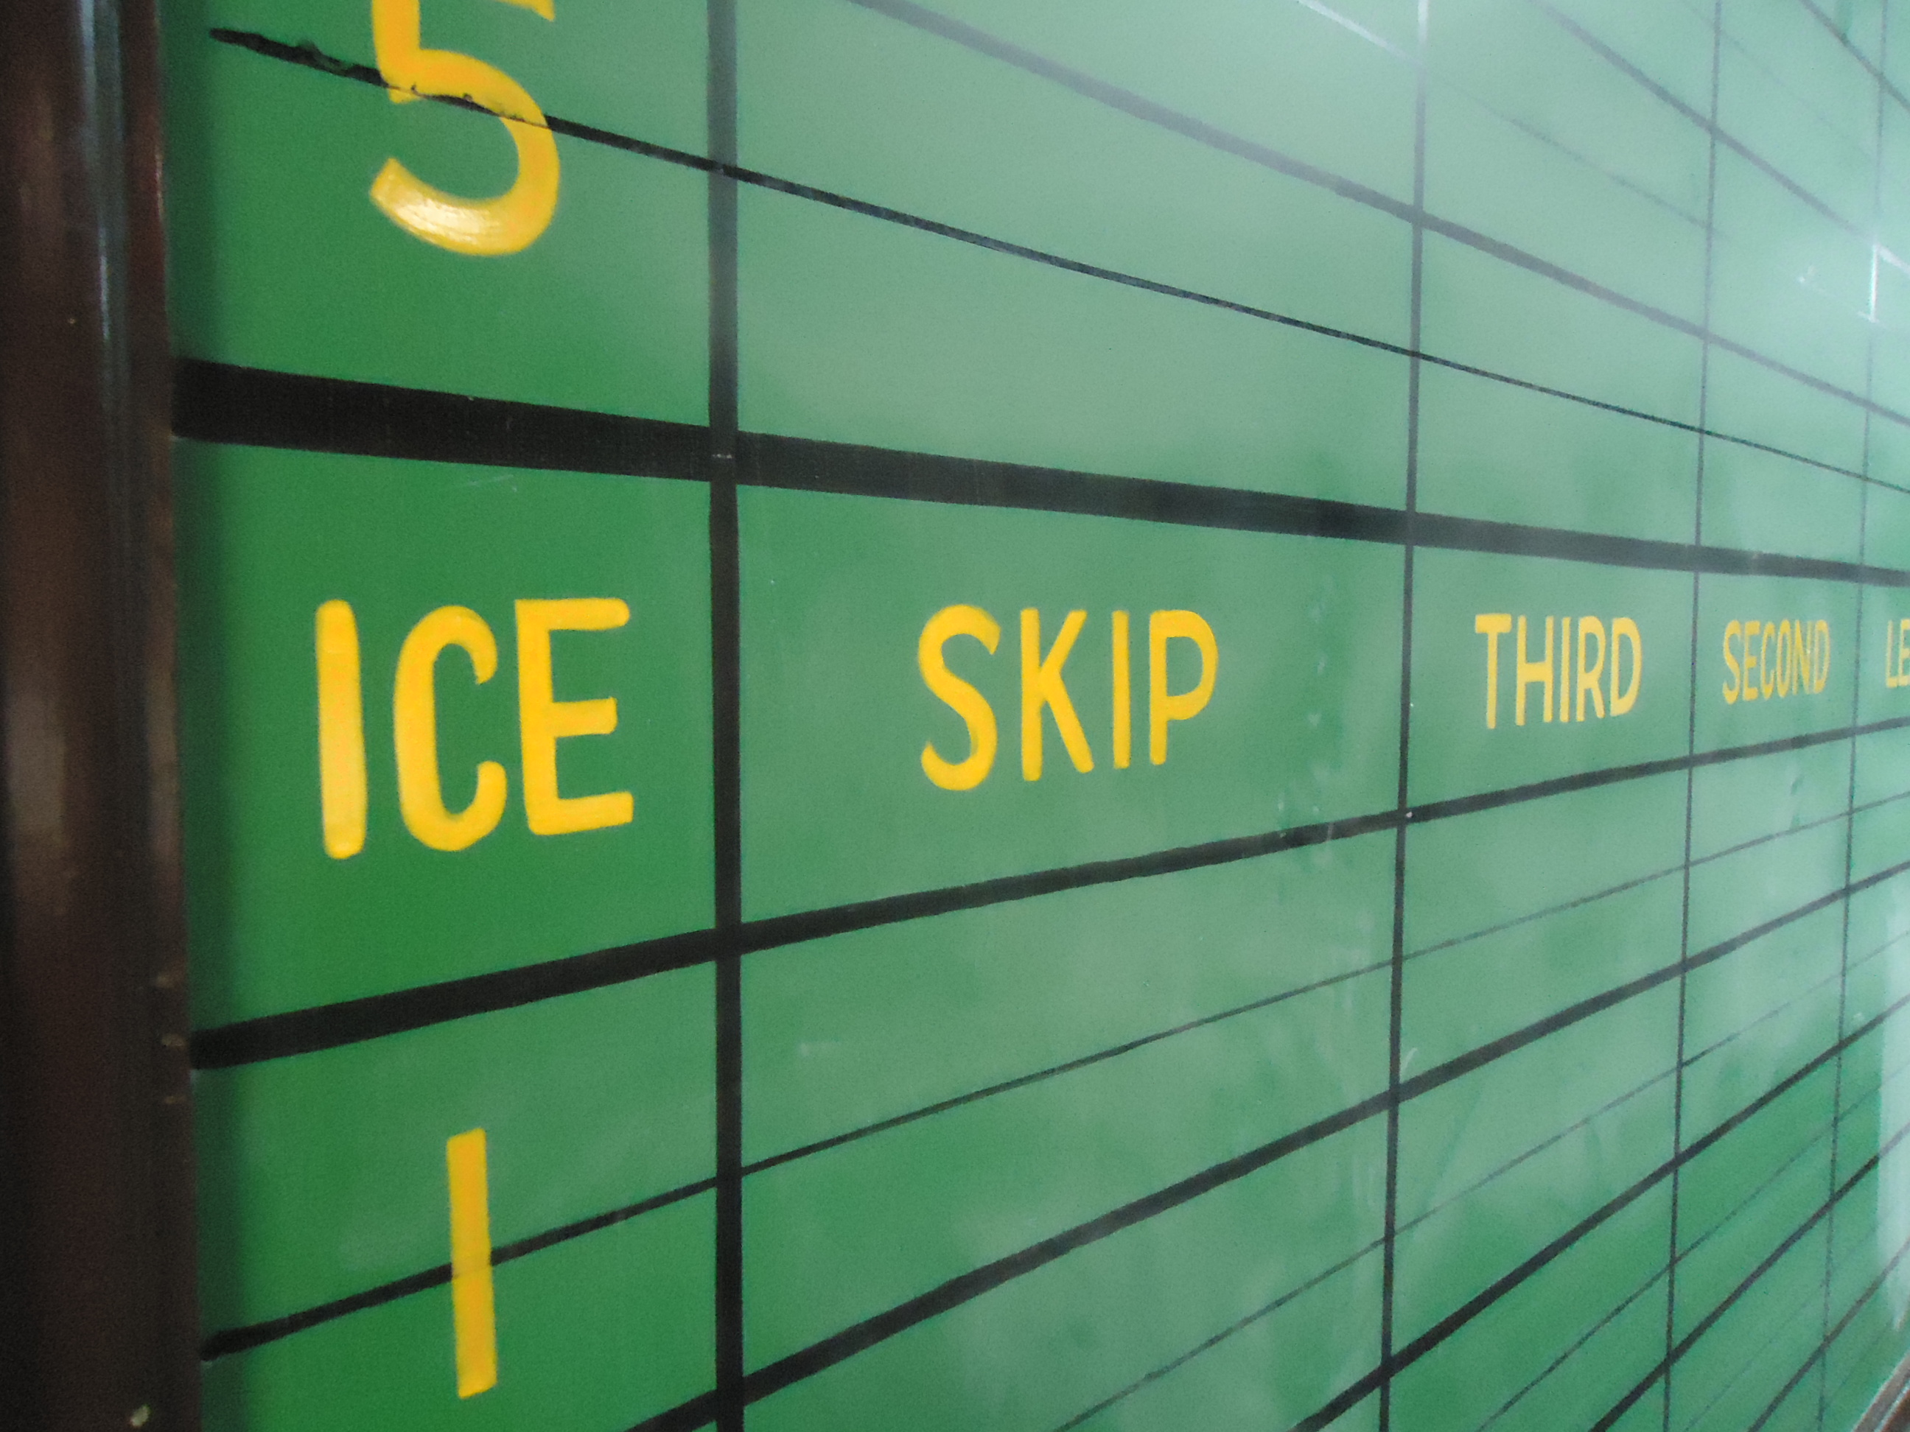
Leagues
If you are interested in playing but don’t have a team please contact the club and we would be glad to help you find a team that suits your skills level.

Special Olympic Program
We will finish our season on Sunday, with a medal presentation and pizza. Our group has made progress this year and some competed in their 1st bonspiel the Curlers Care, enjoying the fun atmosphere very much.
Our numbers dropped with the loss of Rita and Costa, we all miss them. We also had 2 players get injured in off- ice activity and wish them well in their recovery.
Thank you to our coaches Mike Currie and Nicky for their devotion to the group. We are looking forward to seeing everyone back on the ice in November, have a safe and enjoyable summer.
Rand

Junior Curling Program
The junior curling program will run most Sunday’s from 1:00 – 3:00, any interested juniors aged 7 and up can register during the club open house. Registration will be available once the season starts but will be limited to the first 50 paid juniors as in past years. The program offers instruction followed by some game play. New this year is the Inter club Bonspiels. Response to this is great and it gives our curlers a chance to compete against other clubs and form friendship for the future. Our year end fun day is March 26th.
Also, we are looking for volunteers to help for on and off ice activities, anyone interested can contact Don Taylor at 519-380-0413. We look forward to a seeing everyone back next year!
Don Taylor

Mondays Mixed
The Monday Skips Choice Curling league had higher participation this year with 10 teams
of 40 players signing up for Skip’s Choice (the Team Division) and 24 players signing
up for Club Curling.
To add a little excitement, a new tiebreaker system was introduced for the 2016-
2017 season. If games were tied after 8 ends, one rock draws to the button were
delivered by the skips. In the Team Division, 6 ties were broken and one in the Club
Curling Division.
The teams in the Team Division were able to play all other teams twice during the
round robin with Team McKay taking top spot in the standings for the third
consecutive season.
Skip Rob McKay
Third Linda Brown
Second Doug Brown
Lead Kyla Hayward
The season ends this year with a two game playoff format – the top 4 teams playing
in the Mixed Curling Championship bracket, the next 4 teams playing in the “B”
bracket, otherwise known as “We Tried our Best” and the bottom 2 teams playing in
the “C” bracket, otherwise known as “Wait Until Next Year”.
The Team Division season will end on March 27 with a pizza night and the crowning
of the 2016-2017 Mixed Curling Champions.

Our Jitney or Club Curling has helped us grow our membership. This group has teams drawn up for a round robin schedule. After playing each team once, new teams are formed and another round robin takes place. This format allows us to enjoy some old time curling fun along with a great way to meet everyone. This group will hold their year end party on Monday April 7th.

A rare event occurred this year, an 8 ender was scored by the Chinnick rink- with Dave Chinnick, Deb Hooker, Jeremy Schmidt and Lindsay Schmidt. Congratulations!

I thank Rob McKay, Ron and Mary Robertson and Rand MacIntosh for their
assistance in my rookie season as convener.
Allan Klinck

Tuesday Day Ladies
We hope our daytime Ladies enjoyed our events this year.
We started the season with our group hosting the Holly and Mistletoe Bonspiel. Thank you to Maureen Coleman and her committee for their hard work on this event.
Again this year, our ladies volunteered their baking skills to help out with events at the club; this makes it easier for the conveners and on our wallets when we have these donations. Thank you Ladies.
We had 3 draws this year. Our first Draw, the Eva Granger draw, was won by Nora Snelgrove’s team of Anita Quenneville, Jayne Broughton, Linda Bowers and Sharon Isenor.
Second Draw: Maxine DeKoning was won by Dianne Byrnes, Elain Blain, Linda Bowers and Loretta Maceyovski.
Thank you to Elaine Blain and Shelley Kennedy for organizing our Christmas dinner.
Our Tuesday Potlucks were a success again this year and we appreciated the men coming to support our lunches.
Our season will wind down with our last game for the Doris North Draw being March 21. The closing luncheon and meeting will be that day.

Thank you to all who supported our committee this year.
Deb Hooker, Joan Whitson and Jayne Broughton

Tuesday Afternoon Men
We had a fun curling season this year. Our typical attendance was 36 curlers who used all five sheets for most weeks. All the members shared in various tasks such as snacks, the 50/50 draws the button shot awards and various events.
On the first week of curling Paul Johnston convened a successful Tier 55 bonspiel with two full draws. Ten clubs participated. Rob McKay of the Granite club won the first draw and John Fantin representing Leamington won the second draw.
In mid-November, Ron Robertson conducted a skills contest prior to our regular jitney games. The contest coincided with the Women’s Day league potluck lunch.
On December our last day of curling for the 2016 year, we had a turkey shoot prior to our regular game. Martin Forster won the frozen turkey which was donated by Lenovers. Following the turkey shoot we had a regular jitney game but with leads acting as skips.
In mid-January we changed our regular games to a skins format with a purse of $20 per sheet.
Ron Robertson convened another successful Tier 55 bonspiel March 3. Country View Golf and Country Club sponsored the event. We had two full draws and ten clubs participating. Louis Beausoleil from Windsor Roseland won the first draw and Keith Chandler of the Granite Club won the second draw.
The Men’s Day League will donate $500 to the Granite club and $200 to the Curler`s Care Bonspiel.
Our members will participate in the Mixed Bonspiel March 28. We will wrap up the season with a pizza party April 4.

Jim Steele, Chairman Tuesday Men`s Day League

Wednesday Evening League
The Wednesday Evening Women’s League has had an enjoyable curling season. The Christmas Party and the “re-gift” evening provided prizes for all and an evening of fun and laughter. Thank you to all the participants for your faithful attendance and the delicious snacks. Congratulations to the following first place teams:
Draw One – Charlotte Sparks, Deb Gillier, Sandy Ponic, Joan Whitson
Draw Two – Jayne Broughton, Anita Quenneville, Linda Brown, Lindsay Schmidt
Draw Three – Brenda Taylor, Maureen Coleman, Kristy Scamen, Angela Meersseman

A skills competition was held March 15th, with Sandy Ponic winning a one year lease on a “Ford convertible car” in the Chatham Granite Club Hot Shots!

Enjoy the warmer weather and we will see you back on the ice this fall.

Submitted by
Mary Robertson

Maple City League

This league has been in place for over 15 years and offers fun filled competition with food nights added in. Draw times are 5:20 and 7:30 each Wednesday night. There is usually a waiting list for teams wishing to submit their entry. If you are interested in curling in this league contact Rachel Faust or the office, for more information.

Thursday Afternoon Mixed

Happy 90th birthday to Chuck Skipper, a regular at our Thursday afternoon jitneys. Chuck celebrated the milestone in January and he is the oldest active member of the Chatham Granite Club.
Congratulations to two of our regulars Brenda Taylor (vice) and Jim Howe (second)! Along with Jim Brackett and Mary Robertson represented Chatham-Kent District 33A, at the Ontario Senior Games in Coburg. The team placed seventh out of twenty teams. Well done!
We have averaged 36 curlers for the first eighteen weeks of curling. We still have four weeks left, please join us for some curling and fun. Curlers arrive before 12:45p.m., put their names in for the position they would like to play and teams are made up that day. So there is no need to get a spare if you are unable to make it. Play starts at 1p.m. sharp, followed by social time upstairs after.
One week we did a rotation so that all curlers played all positions for 2 ends. Another week, we had a fun day with unusual scoring techniques. On March 2nd, we played Curling Poker.
December 15th, we enjoyed pizza after curling. There will be another pizza day March 23rd. Curlers pay $2 a week which helps pay for the button shots and pizza. The balance at the end of the year will be donated to the club.
Brenda Hoyles – Games Captain

Thursday Flight

This year we have 12 teams participating in 2 flights. Following a 5 week round robin the top 6 teams start the next session in 'A' flight, the remaining 6 teams form 'B' flight. We have had quite a bit of movement between the teams and folks are intently watching the standings. We continue with meal nights. In each of the 5 week round robins 4 teams are tasked with providing food for their fellow competitors. Sometimes a great meal is only a phone call away.
I'd like to thank O'Neill Insurance and Gilanders Heating and Cooling for their sponsorship again this year. They have made possible a season ending skins competition and a closing meal for all of us.
Next year we are hopeful that Ryan Van Praet and his "trust your buddy" curlers will join us on Thursday's.

Rob McKay

Friday Night Curling
Friday Night Curling is a fun-filled relaxing environment for curlers of all ages and skill level. After a long week at work, friends new and old gathered this year to curl and socialize before, during and after their game.
Every Friday we offered two draws: 7:00 and 8:30. This year we hosted new friends from across the country and from around the world. Curlers returned ‘home’ from Ohio, Wisconsin, Illinois, Manitoba, Alberta, British Columbia, and from around Ontario! We also taught new visitors to Canada the ultimate Canadian sport! Young ladies have travelled from as far away as Turkey, Taiwan, and Australia to experience and try curling for the first time!
At Christmas we welcomed our university and college students back. The former Bantam Team (now U-21) competed against the current Bantam Team (U-18) in a one evening showdown. Other students and family from afar arrived home to play with siblings and parents to start their Christmas break. It was a great reunion night for everyone.
After Christmas, the club was busier with Friday Nights making a good practice night or brush up your skills night before a Bonspiel. With the club hosting the mixed-2-day, the Cancer Spiel, Ethan’s Toques and Mittens, and the Curlers Care Bonspiel to Support Our Veterans to name a few.
Friday Nights became an ‘anything can happen kind of night‘… Andrew, Jason, and Kelly are our trivia masters! Hopefully next year we will host trivia night after our on ice time. The Raging Dragons proudly represented Chatham in Ottawa with the first ever Ice Dragon Boat Races to celebrate Canada 150! The Maroon Old-timers along with their friends and families filled the club with their shenanigans. Terrance McNaughton brought in Rotary exchange students from around the world and played against former Chatham students that he sent on exchanges to countries abroad. Pizza Nights and Hot Dog Nights kept Mel busy in the bar and in the kitchen…. Just to name a few…
The season is wrapping up quickly! March 24 is a regular schedule evening. March 31 is our end of year pizza and wings night. Cost $15 per person. April 7 is the final night and Convenors Choice Rules will be in effect if you are interested in playing by a new set of scoring rules. I would recommend that you sign up for the last few nights; spaces can and do fill up quickly. Sign up sheets are on the bulletin board, or feel free to contact John Young Jr or myself to be added to the list.
Have a safe and awesome summer! See you in October!
Judy
cell 519-365-1939 or je1e2@yahoo.ca
House
Hope everyone had a great 2016-17 season.
Recent and upcoming repairs:

- Hot water tank was replaced with a more efficient on demand unit
- We are working on a new dehumidifier for the ice
- Some of the outside wall boards will be replaced over the summer
- A new 55” TV- thank you Dan O’Neill for helping
- Lights on the ice have been replaced
- A new Ice King scraper is courtesy of Guspro. Thank you for your support.
- We are putting plans in place for some new rocks, stay tuned!

With the recent donations from the Ladies and Men day leagues we will be able to do some work on the lounge ceiling. Volunteers will be needed please contact myself, Rand or the office if you are able to help.
I'd like to remind everyone to please let me know if any problems with the building, ice, or property arise. It is important that information is relayed through the proper channels so things can be taken care of quickly and efficiently. I hope everyone has a good summer; I will see you on the ice.
Mark Patterson

Just a reminder curling is only 7 months away

- Learn about What our Club has to offer – We offer a variety of leagues for all ages and skill levels nearly every day of the week for youth to competitive
- Register for Leagues – Sign up as a team or as an individual and we will
help find you a team!
- Sign up for our Learn to Curl Clinic and League. Get weekly instruction and another night of play with some coaching. The best way to learn and practice your new skills
- Meet Members
- Learn to Curl – All you need are Clean Athletic Shoes, Comfortable
Clothing and an Open Mind!
OPEN HOUSE
The Chatham Granite Club invites you to attend our Open House!
Wednesday, October 18th, 2017
7 to 9 pm

The Chatham Granite Club would like to thank
it’s many Sponsors for their generous support for
2016-2017 Season

Alexander / Houle Funeral Home Investors Group- Mike Eddington
All Risks Insurance – Mike Hosfeld Jackson Seed Service Ltd
Al’s Lawn Care JHMI Insurance
Artic Glacier MC Business Solutions
Battery Boy McGrail Farm Equipment
Bayside Breweries McKinlay Funeral Home
Belfor Restoration Micro Age Computer Stores
Beselaere Construction O’Neill Insurance
Blazing BBQ Oriole Wineries
Campbell Toyota Pie-Zano’s Pizza
CM Design & Print Pioneer Hybrid
Chatham Kent Home Building Centre Postma Heating & Cooling Inc
Chilled Cork Pride Seeds
Collins Barrow Quo Vadis Pizza
Country View Golf Course Rona – Chatham
Croplan Genetics- John Young Ross Insurance Brokers Inc
Deer Run Golf Course Sacwall Flooring Centres
Devolder Farms Inc Sentry Fire & Safety Services
Dowlar-Karn Schinkels Gourmet Meats
Drennan Refrigeration St Clair College- Alumni Assoc
Dennings Funeral Home Tek-Savvy
E. Jenkins Landscaping/ May Time Sod Farm
Forsyths Travel Travelers Insurance
Glitters Trevor Hinnegan Law
Handy Brothers Waddick Fuels
Holiday Express Suites WinMar
Z’s Bistro WV Concrete Floors Inc

Thursday Night Flight
O’Neill Insurance
Gilanders Heating & Cooling
DPM Insurance

Please remember to support these businesses when you are out shopping for items you need. They provide a valuable assistance to the club allowing us to operate the many of the community programs we have at your club.

Chatham Granite Club
41 William Street N,
Chatham, ON
Email: granite@ciaccess.com
www.chathamgraniteclub.com

CURLING - “It Rocks!”
A sport for all ages, A sport for life!
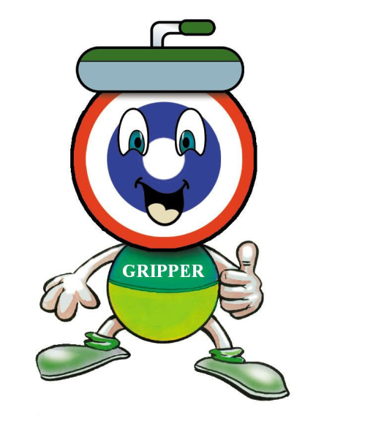

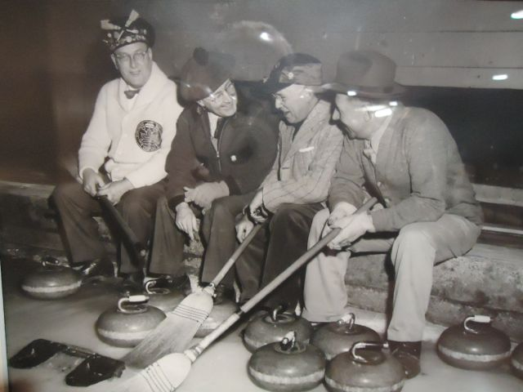
What a Club!
