Granite Gripper
The Chatham Granite Club
September (No.1) | 41 William St. N Chatham, ON, N7M 4L3 519-352-4324
Chatham Granite Club
e: granite@ciaccess.com
facebook/ChathamGraniteClub
chathamgraniteclub.com

Message From the President
Welcome to another year of curling at your club!
The summer has just flown by and there are so many things to do before the season starts. A big thank you goes out to Aiden Poole for revamping our web site www.chathamgraniteclub.com. Check it out along with our other social media sites.
DJ is already in working on getting things ready. Let’s hope the weather cooperates this year for him.
Open house will be Wednesday October 15th and the leagues start up on Monday October 20th. There are numerous other events and bonspiels happening this year, please make note of them and support those you can.
Shop local is not just a buzzword, it is important. We have many local businesses that support our club, with sponsorship and signage. Show these businesses you appreciate their community spirit. They provide valuable funds that allow many programs to continue. Please check the list and say hi, when you have the chance to grace their doorsteps.
We look forward to seeing you on the ice!
Rand MacIntosh
Dates to Remember
Fashion Show – Oct 8th
Open House – Oct 15th
League Start – Oct 20th
Brunches
Sunday Dec 7, 2014
Sunday Jan 18, 2015
Sunday Mar 29, 2015

Getting Involved
There are still lots of opportunities to contribute to another successful season at the Granite Club. Ask one of your board members how you can help.

- Become a member of the board
- Volunteer on a committee
- Help out at bonspiels, fund raising events and brunches.
- Support fund raising events

We are looking for a few members to join the board. We are especially interested in expanding the voice of our members. We welcome new curlers and curlers representing each of our leagues to come out and help the Granite Club.
- Not sure how you could help? Curious what’s involved with becoming a board member? Contact the club or speak to one of your current board members they would be glad to spend some time with you.

- Not sure you have the time to commit to being a board member? How about volunteering to be on one of our committees this year? This is a great way to lend your support and expertise to a board member and your club. Commitments can range from just a few brainstorming sessions to as much time as you can offer each of our board members. Look for a board member at the Open House to learn more or drop your President an email (that’s what he’s for).

Fund Raising
Again this year we are holding 3 brunches so please circle these dates on your calendars.

- Sunday December 7, 2014
- Sunday January 18, 2015
- Sunday March 29, 2015

The committee will again be headed up by Bob Allen, Reg Johnson and Bob Thompson but
we always need lots of volunteer help with donations, cooking, serving and cleanup.

Memberships
Full Membership | $410
Senior Member (60+) | $370
New Member (First Year) | $260
Day Member | $220
Full Time Student | $140
Friday Evening (Per Night (incl HST) | $10
Junior* | $70
Social | $25
Spare by Non-Member | $15
Associate Member | $70
Locker Rental | $25
*A maximum of $125 per family will be charged
Please call or email our office if you have questions regarding memberships.

Bonspiels
Participating or helping organize a bonspiel is a great way to meet new friends and contribute to the Granite Club. The following is a list of the events planned for the upcoming season.

- November 5 Men’s Tier 55
- November 7-9 Chatham Cash Spiel
- December 1 Ladies Holly and Mistletoe
- January 3 & 4 Mixed Two Day
- January 31 Dekoning Senior Mixed
- March 1 Elementary School
- March 6 Men’s Tier 55
Bob Thompson
OCA Intermediates Championship Banner Presentation
The board is working on coordinating a night for our membership to get together and celebrate the success from last season of John Young Jr's team who won the Intermediates provincial championship.

The night will include a steak BBQ and presentation by the Ontario Curling Association. Stay tuned for the date and ticket information. Check the website!

Melanie DeSchutter

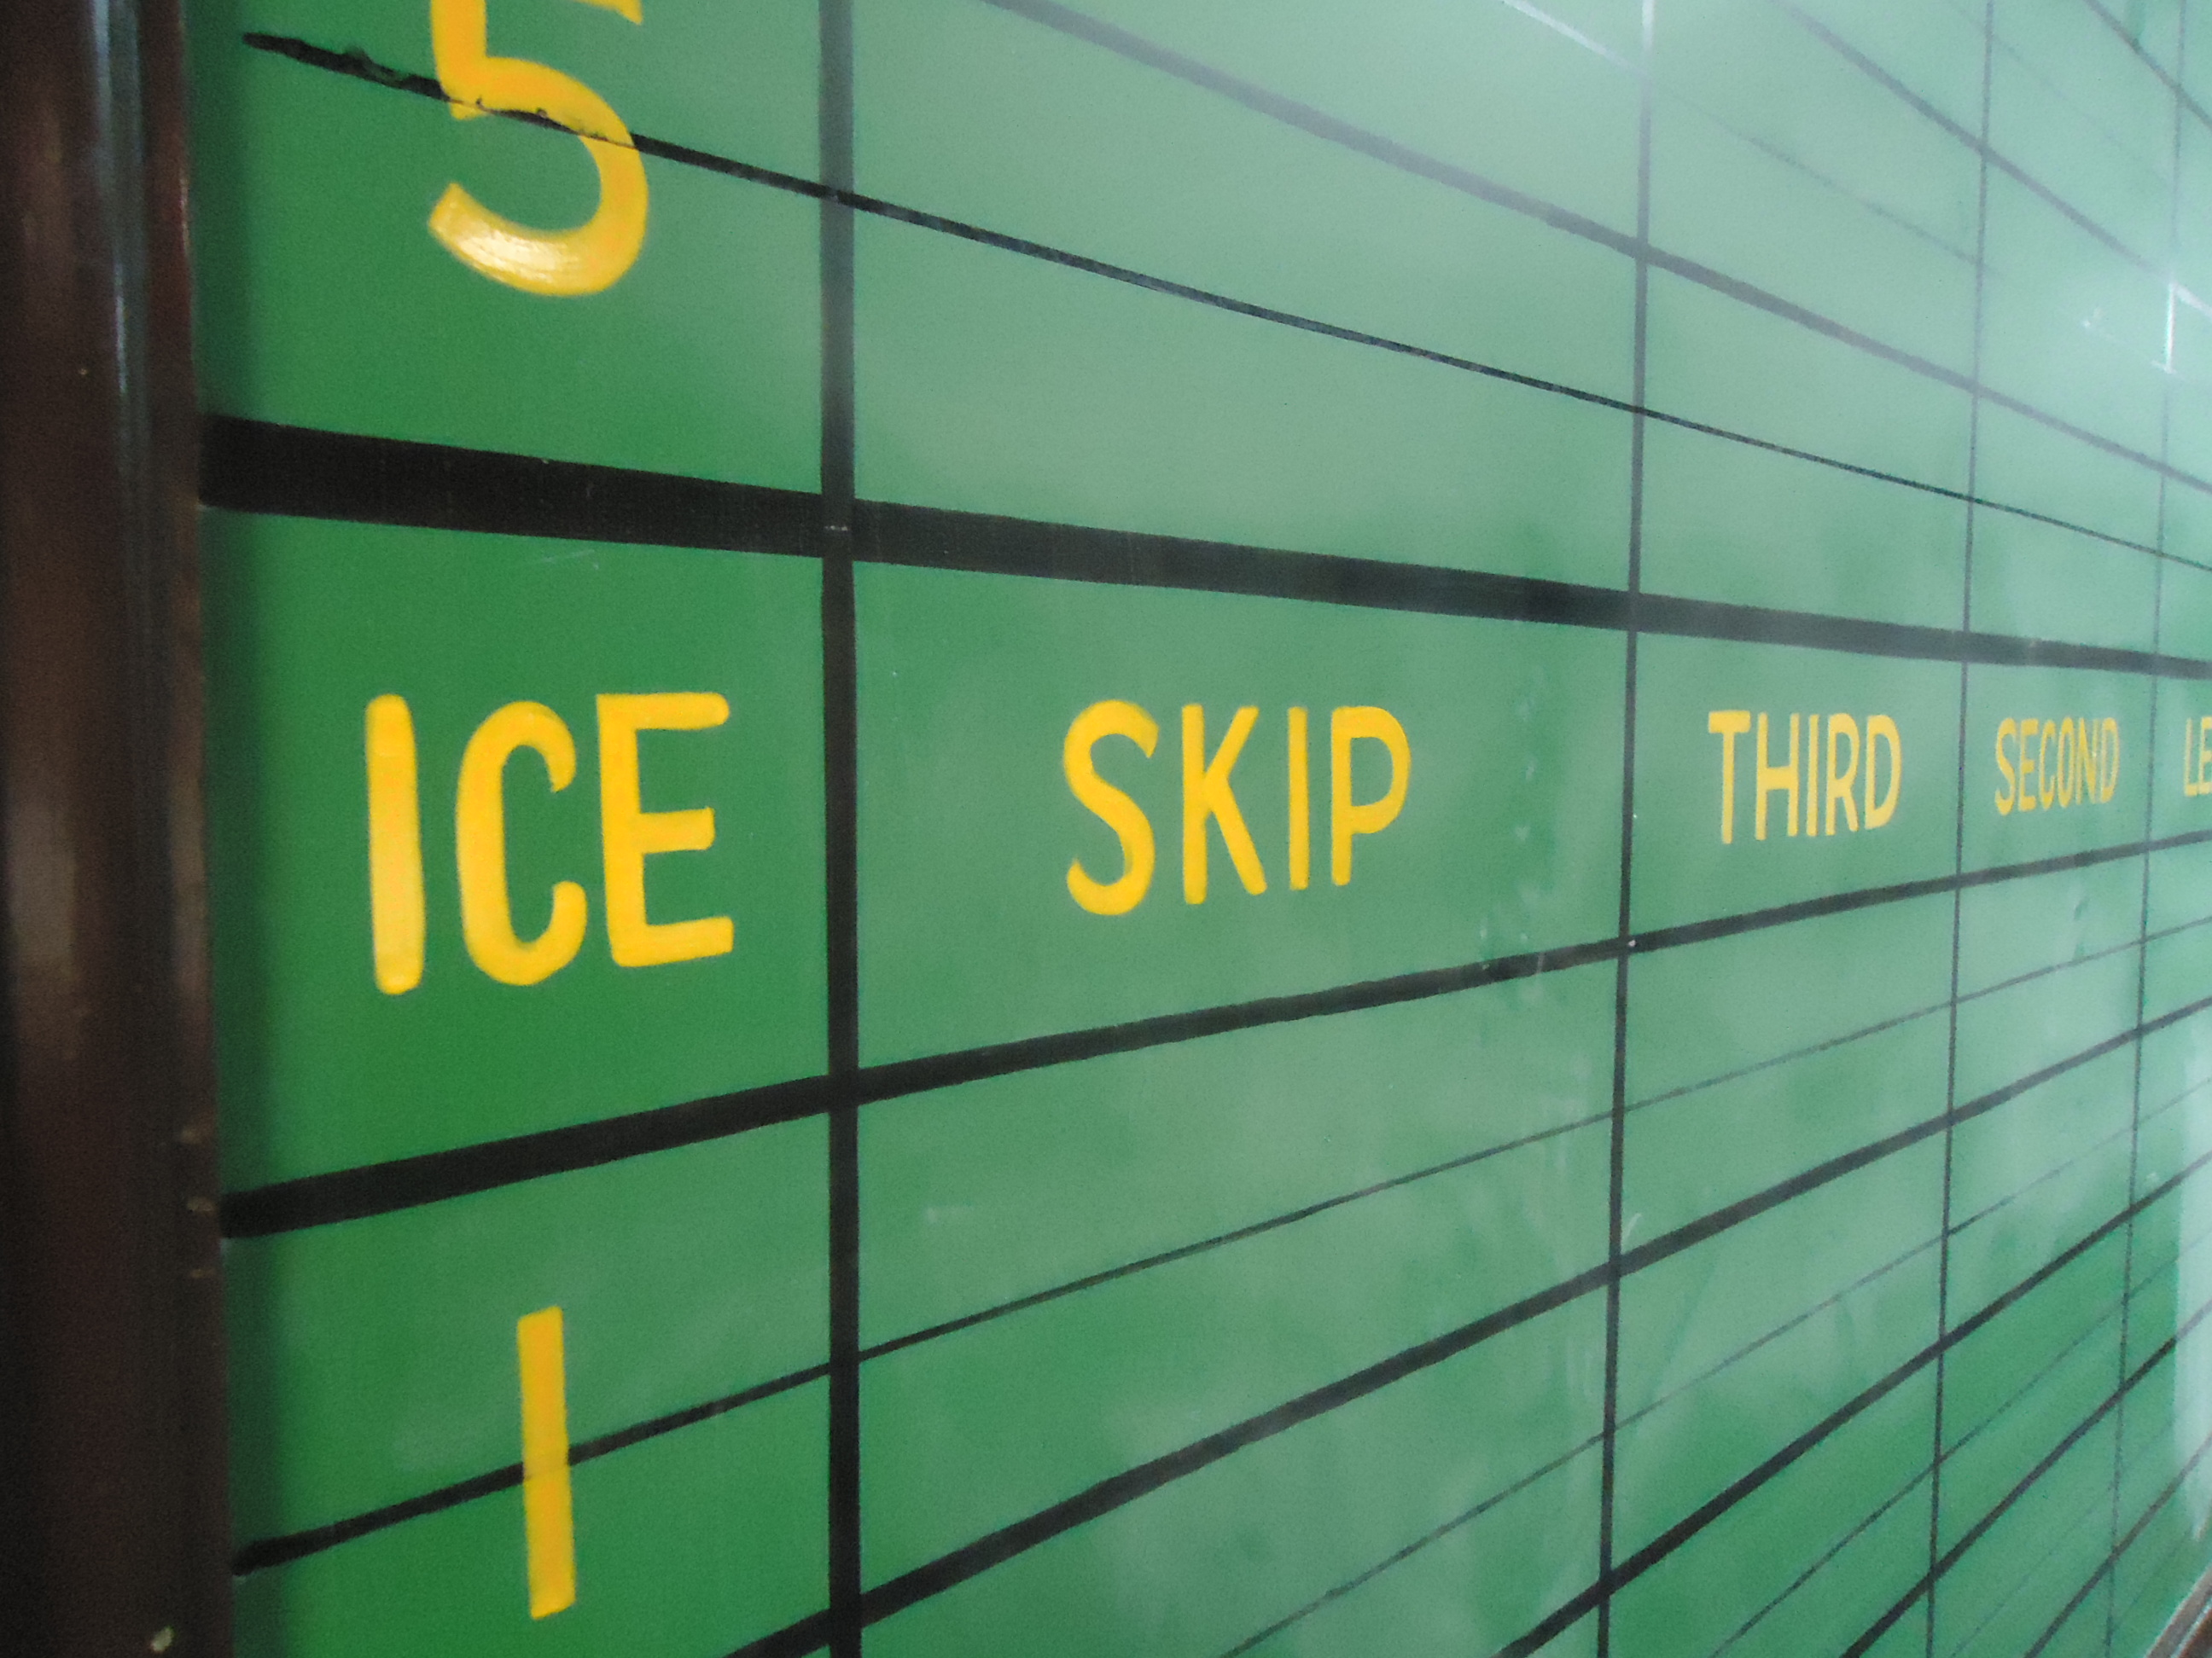
Leagues
If you are interested in playing but don’t have a team please contact the club and we would be glad to help you find a team that suits your skills level.

Mondays Mixed
Combine a night of competition and socializing. For those that want some friendly competition, this is the place. Games are followed by a trip upstairs to the lounge, where each team takes turns supplying the treats. Please join us this year.
Something NEW for this season is the addition of a Jitney draw. One draw will remain a mixed team draw while alternating draws (one week early draw, next week late draw) will be a Jitney format, throw your name in and choose up teams for some old school curling fun, great way to meet new curlers. Monday’s are sure to be exciting this season!
Sign up as a team or we can help you find a team, if you are interested in playing contact the club or see us at the open house October 15th to sign up.

Tuesday Day Ladies
If you are looking for a morning of fun, exercise and fellowship, please come and join the Tuesday Morning Ladies’ League from 9:00 A.M. TO 11:00 A.M. No experience is necessary and instruction will be provided for any new curlers. For more information, please contact Marion Schneider at 519-676-2324.

Tuesday Afternoon Men
The Tuesday Men’s Day League offers an afternoon of jitney style curling, the competition, camaraderie, and socializing after the game makes for a pleasant afternoon. During the season we have special events, prizes and draws.

Come join us for exercise, fun, and relaxation at 12:30 p.m. every Tuesday to sign up for teams.

Wednesday Night Ladies Curling
With the curling season fast approaching, all ladies are invited to come and join our Wednesday Night Ladies League for good curling, great fun and enjoy camaraderie. No experience is necessary as instruction is given at the club during the first two weeks of curling. For more information, phone Brenda Taylor at 519-354-1212 or phone the CGC.
Our ladies league is sponsoring a fashion show at the CGC on Wednesday October 8th at 7 pm (doors open at 6:30 pm). Tickets are $10 each, which includes homemade desserts, coffee/tea and fashions from Nina Marie’s. For tickets phone Lynda Faulkner at 519-352-2079.
Brenda Taylor

Thursday Afternoon Mixed
Well here we are again. Another summer has gone and another curling season is starting.
We had a very successful season last year with a number of new members. Remember Tuesday and Thursday daytime curlers to mark your calendars for the golf social on October 2 at Country View Golf Course. If you need details, let me know and I will fill in the blanks. (Delbert 519-354-3463) Hope to see you and your friends at the golf course and at the curling rink.

Delbert Lorenz

Thursday Flight
Hope everybody enjoyed the summer! Curling season is just around the corner. The first night of Thursday Night Flight will be October 23th. We had a very successful year last year, so we’re hoping to build on that. We will be contacting the skips over the next week or two to confirm your teams for the upcoming season. If anyone knows of people looking to get back into curling, let me us so we can help them find a team. See you at the Open House on October 15. Ed Deschutter

Friday Night Curling
This is a unique league in that it allows both members and non-members the opportunity curl. It is a jitney format where the teams are made up prior to going on the ice for our 7 p.m. start. Fees for this league are included in the full membership. For non-members you can “pay-as-you-play”, $10 for each Friday night that you play. Pay as you play cards are also available to non members. This entitles the individual to 6 plays for $50.
This league is the perfect place if you are looking to be introduced to the game of curling or for an experienced curler looking to share their love of the game with those who are just starting out.
Two dates to keep in mind are the first night of Friday night curling. Tentative start date is Fri. Oct 24. The second date is the night for the closing Friday night bonspiel, Fri. Mar. 27 2015.
For more information on this league, please contact Paul Bowman @ 351-6239 or pbowman6@cogeco.ca
Paul Bowman

Junior Curling Program
The junior curling program will run most Sunday’s from 1:00 – 3:00, any interested juniors aged 7 and up can register during the club open house. Registration will be available once the season starts but will be limited to the first 50 paid juniors as in past years. The program start date is TBD, more information will be available at the open house. Also, we are looking for volunteers to help for on and off ice activities, anyone interested can contact Don Taylor at 519-380-0413. We look forward to a great curling season!
Don Taylor

House
Welcome back to the Chatham Granite Club for the 2014-2015 season.
Recent and upcoming repairs:

- Flat roof required repair and will require major repairs in the coming years.
- Roof and eaves troughs by the compressor room was repaired
- Drainage at the back wall of the curling rink and new tile will be installed.

I'd like to remind everyone to please let me know if any problems with the building, ice, or property arise. It is important that information is relayed through the proper channels so things can be taken care of quickly and efficiently. I hope everyone has a good season; I will see you on the ice.
Mark Patterson

OPEN HOUSE
The Chatham Granite Club invites you to attend our Open House!
Wednesday, October 15th, 2014
7 to 10 pm

- Learn about Leagues – We offer a variety of leagues for all ages and skill levels nearly every day of the week including Junior curling
- Register for Leagues – Sign up a team or as an individual
we’ll help find you a team!
- Signup for a FREE Learn to Curl Clinic (Friday October 17th 7-9pm or Saturday October 18th from 9-11am)
- Meet Members
- Learn to Curl – All you need are Clean Athletic Shoes, Comfortable
Clothing and an Open Mind!

NEW MEMBERS
ONLY $260 FOR SEASON!
October - April

Chatham Granite Club
41 William Street N,
Chatham, ON
Email: granite@ciaccess.com
www.chathamgraniteclub.com

CURLING - “It Rocks!”
A sport for all ages, A sport for life!

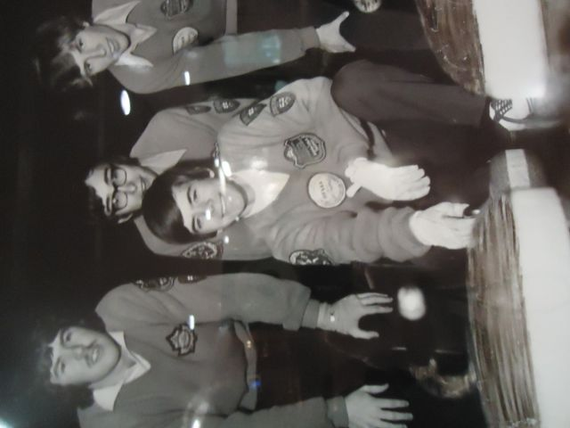
What a Club!
