Granite Gripper
The Chatham Granite Club
April (No.3) | 41 William St. N Chatham, ON, N7M 4L3 519-352-4324
Chatham Granite Club
e: granite@ciaccess.com
facebook/ChathamGraniteClub
chathamgraniteclub.com

Message From the President
Well another year has come and gone! I would like to thank everyone for all their time and effort in supporting the different functions around your club. There are a number of people who make all of the activities possible. Without their assistance bonspiels, brunches, junior curling, school program etc would not happen.
Thank you to all the volunteers
On Wednesday May 27th 7pm is our AGM. Please mark it on your calendar; we look forward to seeing everyone there.
In the very near future, you will be asked to support our fundraising for the roof repair. Melanie and Matt have put some time into getting this project organized, please support this important project. We already have some donations from the Day Ladies and Men’s group and Daytime Mixed, thank you to these groups for their kind generosity.
We lost a few friends and curlers this year, we would like to pass on our condolences and ask that you all remember them as not just our friends, but family - Tom McNaughton and Jack Pearson.
Have a wonderful summer see you in the fall.
Rand MacIntosh
Dates to Remember

AGM – May 27th

Raise the Roof fundraiser – see info in this Gripper

Check the website for more…
Getting Involved
There are always lots of opportunities to contribute to a successful season at the Granite Club. Ask one of your board members how you can help.

- Become a member of the board
- Volunteer on a committee
- Help out at bonspiels, fund raising events and brunches.
- Support fund raising events

Special Thanks
As most of you know Paul Bowman, is stepping down from his role of coordinator for the Friday night league. He has devoted many years to the club, his passion for the game and friendly nature are the reason Fridays were so successful.
We want to thank Paul for giving so much back to the club and the game of curling as well. Many of the current members all started with a little push from Paul.
Notes
- Just a reminder that there are members who are sensitivity to fragrances, please be mindful of others while attending activities at the club.
- We are always looking to hear from the membership on ways we can improve the club
- Take some time to consider volunteering next season your club depends on it.
Thank you, your Board
Fund Raising
The School program is another important component of the club. The volunteers Jean Dumoulin, Bill Reaume, Don Braddon, Gord Wells, John Shields, Keith Chandler, Sandy Fraser, Paul Johnston, Reg Johnson, Ron & Mary Robertson and Myles Jackson who spend a lot of time and effort, making the kids feel welcome and introducing them to the great game of curling. These folks raised over $10,000 this year, well done!!
Shop local is not just a buzz word, it is important. We have many local businesses that support our club, with sponsorship and signage. Show these businesses you appreciate their community spirit. They provide valuable funds that allow many programs to continue. Please check the list and say hi, when you have the chance to grace their doorsteps.
RAISE THE ROOF (more details at the end of this Gripper)
We had three very successful Sunday Brunches this year thank you to all the helpers! There are too many to mention, but all of their help makes this program work. The brunches raised $3,600 this year!

OCA
The Chatham Granite Club had a great showing this year in a number of OCA events.
Congratulations go out to the Provincial Champions in Men’s Silver Tankard. The teams of John Young Jr, Brett DeKoning, Graeme Robson, Jaques Van Bilsen and Dale Kelly, Mark Patterson, Ed DeSchutter & Blair Willert won the Championship at the Annadale Golf and Curling Club in Ajax on Sunday, April 5th.
Charlene Haluk-McMahon and Melanie DeSchutter won the Women’s Tankard playing out of the Ilderton Curling Club on Sunday, April 5th at the Annadale Golf and Curling Club. What a great way to end the competitive season!
Seniors – The team of Phil Daniel, Kevin Daniel, Ross Adamson and Peter DeKoning advanced to the Senior Men’s Provincial Finals at the Glencoe Curling Club. The team had a strong showing and represented the Chatham Granite Club very well.
Juniors – Congratulations goes to the Chatham Kent Secondary School team for qualifying for Gore School Boy and OFSAA this year. Skip Tye Juniper, Aiden Poole, Noah Link, Devon Weese and Coach Wayne Sass
Aiden Poole qualified for Junior Provincials and Junior Mixed Provincials curling out of the Woodstock and Brant Curling Clubs.
Colts – The team of John Young Jr, Ken Baute, Graeme Robson and Andrew Willemsma along with the team of Dale Kelly, Mark Patterson, Ed DeSchutter and Blair Willert all advanced to the Colts Provincial Championships at the Quinte Curling Club in Belleville.
Trophy – Congratulations to Charlene Haluk-McMahon and Melanie DeSchutter who advanced to Trophy Provincials playing out of the St. Mary’s curling club.

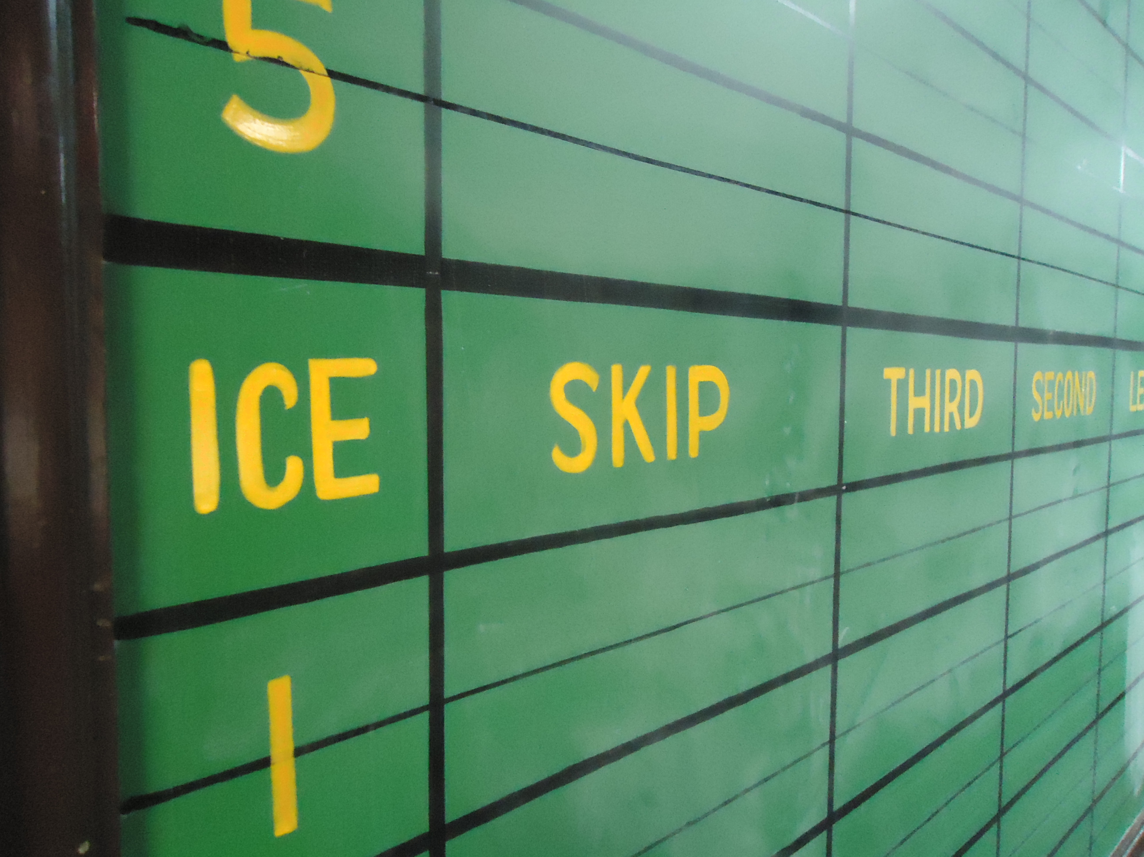
Leagues
If you are interested in playing but don’t have a team please contact the club and we would be glad to help you find a team that suits your skills level.
Mondays Mixed
Wow has the year flown by….
To me the year was most enjoyable, a lot of fun on and off the ice, possibly due to the assistance of Judy. She offered to take on some of the work this year and I would like to thank her for her time and efforts. Hopefully she will be back again next year.
We have just finished our year end party on March 30th. Thanks to Melanie our bartender for preparing the delicious meal and to Judy for her assistance in the kitchen and with the special prizes.
We had a great bunch of curlers, with some new ones that we hope felt welcome to their new club.
Thank you to everyone for all your support this year, have a great summer and I look forward to seeing everybody back on the ice, next year.
Judy & Rand
Tuesday Day Ladies

Jayne & Brenda

Tuesday Afternoon Men
We had a very successful winter season with near full attendance through the month of January before some members headed south.
In January we scheduled a skin game at the same time as the women had their pot luck lunch. This is the highest attendance by the men’s league to the pot luck. Dennis Maceyovski ( a new curler ) and Fred Hargrave organized the skins game.
The March SWOSMBA bonspiel organized by Ron Robertson was able to fill the two draws by the end of January. This bonspiel is so popular we had 16 outside teams attending.
The Men’s league lost a long time member with the passing of Jack Pearson. He ran the season end mixed day league bonspiel for many years. The women’s league took on the job of convenor with the help of the men’s league.
The Men’s League has donated $700 to the Granite Club to help with the reroofing fund.
Ron Robertson organized a group from the men’s league to sand and paint the bases of the lockers in both the women’s and men’s change rooms.
Jim Steele

Wednesday Night Ladies Curling
Our ladies group had a very successful curling season and wound up with a closing dinner on April 15th. The winning team of the second draw was the Deb Gillier team of Kyla Hayward, Bonnie Van Bavel and Sophie Jefferson. The overall winners of the third draw were Mary Robertson, Linda Brown, Deb Hooker, and Vivianne DeWitte. Congratulations to all the winners.
With our successful fundraising over the past few years, our ladies league will be donating $3500.00 to the club for repairs on the roof. Wishing everyone a safe and happy summer and hope to see all out again for the new curling season in the fall.
Brenda Taylor

Thursday Afternoon Mixed
Delbert Lorenz

Thursday Night Flight
Thank you to everyone who participated in the Thursday Night Flight league this year. It was a fun season; I look forward to seeing everyone out on the ice again next season.
Ed Deschutter

Friday Night Curling
We had a tremendous turn out of pay as you play members for Friday night curling this year. We also had a great mix of some experienced curlers who came out Friday night’s this year to help the new folks. Hopefully we can convert some of this year’s pay as you play members into club members next year!

I would like to thank our experienced members that took time to instruct our brand new curlers when the new curlers came out to Friday night curling.

We had 56 people sign up for the year end mini bonspiel on March 27. Where else could you enjoy great companionship, two games of curling, pizza & wings & a trip to the prize table for $10
I will be stepping away from running the Friday night social curling. I have been involved in running the Friday curling program for a portion of the 80’s, the 90’s & from 2003 through to the present time. I think it is time for someone else to have the fun of re-arranging the board @ 6:55 on a Friday night
It is hard to believe how quickly time has passed. I would like to thank everyone that has helped out through the years. We welcomed a lot of new curlers to the club through the Friday night program. Thank you to all those folks over the years that I would ask to provide instruction to new curlers by giving them the “short course” on the game. You did this without hesitation & certainly promoted the game to new curlers.
Throughout the years I have made a lot of great friends from the people that have come to join us for Friday night curling. I hope to continue those friendships as I step away from the game a little bit.
Finally, this is not the end of curling for me. I will make token appearances for Friday night curling in the years’ to come as curler not as an organizer.
Good Curling everyone!!!!
Paul Bowman
Junior Curling Program
The junior curling program was a great success this season. Thanks to everyone who came out volunteers and curlers. We are looking for volunteers to help for on and off ice activities next season, anyone interested can contact Don Taylor at 519-380-0413. We look forward to next season!
Don Taylor
Special Olympics
Our group has grown again! Every week the group enjoys a bit of instruction followed by hot chocolate and then a game to finish the day. Strategy and challenges are always part of the discussion.
We finished our year with a challenge game between parents and participants, followed by a small get together. Thanks to the family and friends of our participants for your help and also to my assistant coach Nicky, it has been a fun year.
On behalf of the club, we hope that everyone has a wonderful summer and we look forward to having you all back next year.
Rand
House
I'd like to remind everyone to please let me know if any problems with the building, ice, or property arise. It is important that information is relayed through the proper channels so things can be taken care of quickly and efficiently. Have a great summer, see you next season.
Mark Patterson

Chatham Granite Club
Raise the Roof Fundraiser
Rock Handle Engraving Order Form
Please complete the attached form, and return to the Granite Club with payment enclosed.

Rules: Three lines of text maximum, 18 characters per line.

Note: this includes all punctuation and spacing. No profanity or insults allowed. Each message is accepted pending Raise the Roof Fundraiser committee approval for suitability and language.
Please ensure all spelling and grammar is correct, please PRINT each message clearly.

Pricing:
Single Side $150.00
Both Sides $250.00

There are a total of 80 Rocks, two sides per rock for a total of 160 spaces. Spaces are available on a first come first serve basis until they are sold out. This process will have no effect on the curling season. All engraving will be done during the off season. Rocks and position of message will be assigned at random.

Questions please email melanieur@hotmail.com

NOTE: EMAIL ORDERS WILL NOT BE PROCESSED
Thank you for Supporting your Club!

Raise the Roof Fundraiser Order Form
Member Name:
Side 1 Line 1:
Side 1 Line2:
Side 1 Line3
Side2 Line 1:
Side2 Line 2:
Side2 Line 3:
Payment:

